-as of March 17th,2011 this version is not updated anymore-
we switched to an offline version. Contact brunosan@gmail.com for an updated copy

Scoping Gain™

Executive Summary

This document describes the first working draft for GaIn™. It explains how and why indicators were chosen to measure a country’s Readiness (to adapt) and Vulnerability to the impacts of climate change. It also shows how the indicators are combined to produce the overall measure of both Readiness and Vulnerability. We anticipate many changes and improvements in our draft model. However, we believe this model reflects a sensible approach based on our present understanding and review of numerous indices and academic papers.
This work builds upon the GaIn™ Oct. 2010 experts meeting on global adaptation metrics, indices, and indicators. A consensus that adaptation metrics are untested, hindered by fragmented expertise, and politically contentious emerged from this meeting. Further review and expert consultation has born this out. However, we can usefully build upon the work that has been done. Following advice from this meeting, the GaIn™ working team has used existing indices and/or frameworks as much as possible and included indicators that are transparent and easy to understand by stakeholders.
Also, GaIn™ has closely heeded warnings that uncontrollable exogenous factors not dominate the rankings while still being accounted as contributors to vulnerability. As explained in the Vulnerability section, we feel that classifying indicators into those that can be changed quickly and those primarily biophysical exogenous factors can motivate users to change those indicators they can change while understanding the contributions of less controllable factors.
Initially, we undertook a broad, in-depth review of the climate adaptation literature and the potential indices (see bibliography). This step provided insight into the categorization of indicators and their usefulness. Second, we consulted several in-house experts to review our initial methodology and indicator selection. Third, we used both qualitative and quantitative methods to ensure that indicators were relevant and not overlapping or overly-correlated.
Throughout our indicator selection process, we tested each indicator against several quality control criteria.
● Coverage: Does the indicator cover sufficient countries to ensure global representation?
● Access: Are the data easily available and open to the public for scrutiny?
● Credibility: Is the institution responsible for conceptualizing or collecting data on the indicator authoritative, often-cited, and experienced in the subject matter?
● Effectiveness: Is the chosen indicator appropriate for representing the condition we are measuring or are there potentially better ones for which data must be collected?
● Longevity: Will the indicator likely exist for many years?

Readiness indicators are divided into three categories -- Economic, Social and Governance. The indicators chosen to represent each are the Index of Economic Freedom, Human Development Index, and World Governance Indicators. Eventually a fourth category, “Awareness,” which will consist of country surveys developed by GaIn™ in consultation with experts will be included.

Vulnerability indicators are divided into three categories -- Biophysical Exposure, Socioeconomic Sensitivity, and Adaptive Capacity. This categorization and sector selection is based primarily on a model developed by Hans-Martin Fussel (2010). Initially each vulnerability category contains an indicator to reflect changes in each of four sectors, Food, Water, Health, and Coastal Zones. Additional sectors such as energy, agriculture/ecosystems and infrastructure may be included in the future.Indicators within each of these categories can be described as slow, medium and fast adjusting indicators. GaIn™ believes this description will help countries better understand improvement in which indicators are likely to “move the needle” the most.

An overall Readiness and Vulnerability score is calculated by weighing the standardized scores for each indicator and summed as described below. The total GaIn™ score is the total Readiness minus total Vulnerability, leading to the global GaIn™ ranking (link).

We also prepared a short presentation with slides depicting the process.

Definitions

Adaptometer | an indicator that captures information from the field that describes the level of knowledge, the policies in place, the allocation of budgets, and the overall commitment of society to adapting to climate change and other global trends. The adaptometer will not only capture the “awareness” of the public and government on adaptation but what actions are being formulated and implemented.
Awareness | a concept that captures the reality on the ground, a society’s understanding of climate risks, and the prospects of change in the right direction for increasing adaptation capacity.
Biophysical impacts | the level of adverse biophysical impacts due to climate change and other global forces
Fast indicator | an indicator that can change quickly, primarily due to human actions. Most Readiness and adaptive capacity indicators are fast indicators.
GaIn™ | Global Adaptation Institute. A non-profit environmental organization guided by a vision of building resilience against climate change and other global forces as a key component to sustainable development. The mission of GaIn™ is to enhance the world’s understanding of the urgency for adaptation to climate change and other global forces and for the support needed through private and public investments for developing countries.
Medium indicators | an indicator which can change over time due to human actions. However, change may take place slowly, over decades rather than years.
Readiness | a country’s existing preparations and ability to adapt to a changing climate.
Readiness Matrix | a measurement of the comparative resilience of countries, plotting a country’s vulnerability to climate change with its readiness to confront climate challenges.
Slow indicator | an indicator, usually physical, that moves very slowly or may not change in a lifetime. Human action has little impact on changes in these variables.
Socioeconomic exposure | the importance of a climate-sensitive sector to a country. In other words, how exposed or sensitive a country is to impacts on water, food, coastal zones, and human health.
Socioeconomic adaptive capacity | the availability of economic, social, and institutional resources to cope with and adapt to the impacts of climate change in specific sectors. Though related, this differs from Readiness indicators in that it measures specific actions taken to increase resilience in specific sectors, whereas Readiness measures a country’s ability to easily facilitate these increases in resilience.
Vulnerability | a country’s socioeconomic exposure to biophysical impacts minus adaptive capacity
Weight | the relative value or importance an indicator is assigned in determining a country’s overall Readiness and Vulnerability score.

Model

This section describes step-by-step how values are assigned to countries for each indicator and how they are then combined to create Readiness and Vulnerability scores.

Implementation

This first working model for GaIn™ was implemented using Google Docs Spreadsheets. The complete model, resources, indicators, weights, calculations and results are available at this address. There is open access to view, but not edit. The model is for circulation only within the limited consultation group. Please do not share with those outside this process.
The current version approaches the operational limits of Google docs. Since we aim to maximize transparency, OpenSource and OpenData for GaIn™, future development, beyond this version, will be in another framework.

Gain™ Structure

2 Axes: The Readiness Matrix as shown at the launch of the GAIN™ has two axes, Readiness and Vulnerability.

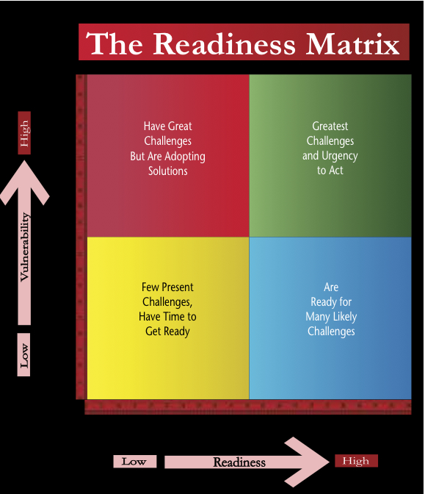

Readiness: A country’s existing preparations and ability to adapt to a changing climate. The axis has 3 categories: Economy, Social, and Governance and a placeholder for Awareness. A weighting is shown below each indicator within the three categories:
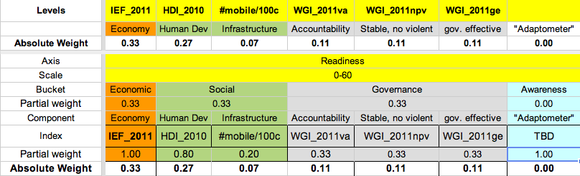

The three categories receive equal weight (33%). Indicators within the categories (and their weights) are:
33% Economic: Ability to provide a hospitable financial and regulatory investment environment.
100% Index of Economic Freedom 2011.
33% Social: The human and physical capital available to transform investments into effective projects and climate resilient enterprises.
80% Human Development Index 2010 [UNDP].
20% Infrastructure. Proxy: mobile phones per 100 people, in 2009. [ITU]
Rapid access to information, communication, etc. that enables an economy to respond quickly to a crisis.
33% Governance: Strong institutions will ensure that investments more effectively meet the needs of the population.
From the World Governance Indicators 2009 we chose 3 sub-components that do not overlap with the Index of Economic Freedom. They are equal weighted [Kaufmann]
33% Voice & Accountability.
33% Political Stability & No Violence.
33% Government Effectiveness.
Vulnerability: Captures exposure to climate related hazards, sensitivity to their impacts and the ability to cope with those impacts. Vulnerability, as represented below, has 3 categories (rows), and 4 key sectors indicators for each category (columns). In this initial version of the index a single indicator was selected for each of the sectors within each of the categories. Each category has equal weight, but the indicators for the specific sectors have different weights, namely food = 0.33, water = 0.33, health = 0.22, coastal = 0.11. The index represents high vulnerability by larger scores which means that the weighting for some indicators is negative. These are shown below.

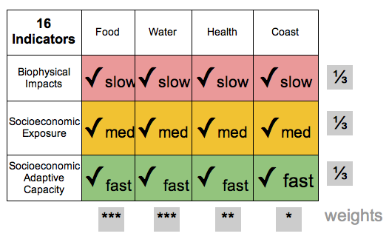

The indicators used are:
33% Biophysical Impacts: The level of exposure to adverse biophysical impacts for a given magnitude of climate change (slow adjusting).
33% Food: Predicted cereal crop yield decrease per country [Wheeler based on Cline]
33% Water: Projected future percentage precipitation decrease [CRU & 9 model A2 scenario]
22% Health: Proportion of population affected by climatic events in recent decades [CRED]
11% Coast: Percent of national land area less than 5m above sea level [PLACE]

33% Socioeconomic exposure: The importance of a climate-sensitive system or sector for a country (adjust at medium rate).
33% Food: Percentage of total population classified as rural [WB]
33% Water: Annual freshwater withdrawal [WB]
-22% Health: Doctor/Nurse numbers per 1,000 [WB]
11% Coast: Percent of population living less than 5m above sea level [PLACE]

33% Socioeconomic Adaptive Capacity: The availability of economic, social, and institutional resources [for specific sectors] to cope with and adapt to the impacts of climate change (fast adjusting).
33% Food: Depth of hunger measured as deficiency in Kcal/person/day [WB]
-33% Water: Percentage of population with access to water and sanitation [WB]
22% Health: Infant Mortality per 1000, 2009 [WB]
-11% Coast: Measure of financial resources that might be applied to coastal protection: $PPP per km2 of coast area [WB and PLACE]

Weights
Whenever possible we try to obtain a complete set of the best, most general, independent, and comparable Indicators. Therefore, our preference is to weight all components equally. These are the exceptions:
● We weight Readiness stronger than Vulnerability because of our focus on promoting societal and governmental change and investments that create tangible improvements -- Vulnerability indicators are more static. Therefore, to compute the total country scores, we rescale Readiness scores to a global maximum of 60 and Vulnerability to a global maximum of 40.
● The Awareness component is not yet ready, and therefore currently has 0 weight.
● The Human Development Index (HDI) measures social Readiness. We also include an infrastructure and communications component that reflects physical capital which is not captured in HDI. HDI receives 80% of the social category weigh and the number of mobiles per 1,000 habitants receives 20%.
● For Vulnerability, the Food and Water sectors receive stronger weights (33%). Health is weighted slightly less (22%), and Coast has the weakest weight (11%). This weighting scheme reflects an emphasis on sectors GaIn™ believes to be more important to our mission of improving lives and investing in sectors than can have the highest impact in reducing vulnerability. Improvement in Food and Water sectors will also contribute to improvements in Health, so the effective weighting for Health is high.

Methodology

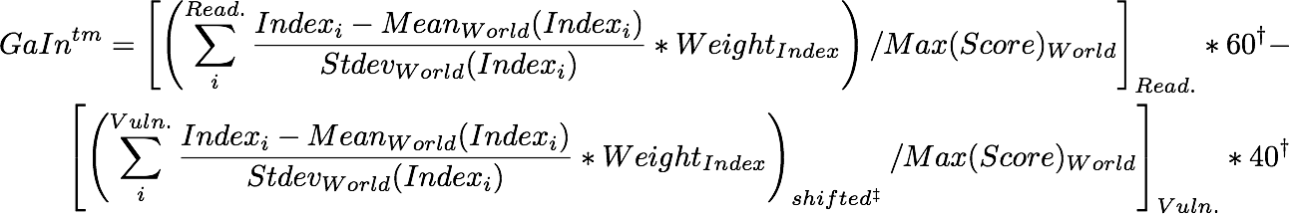

Footnotes:
† For the total Score, Readiness values 60%, Vulnerability 40%.
‡ Vulnerability score can be negative, we shift everything so it starts in zero.

  - Each Indicator is converted into standardized scores (z-value) within available countries.
  - Scores for each Indicator are weighted and aggregated (sum).
  - Since summed vulnerability scores can be negative, Vulnerability scores for each country are equally shifted to make the most negative score equal to zero.
  - Scores for each axis are rescaled (max 60 for Readiness, max 40 for Vulnerability).
  - The overall GaIn™ score is calculated as Readiness minus Vulnerability, producing a global ranking.
  - We also produce the percentage change in Readiness score over the past 5 years. In this case the scores are not the latest value as above, but the change between the latest and 5 year previous scores divided by the geometric mean of those two scores. Indicator weights remain the same. The weighted sum of these percentage changes are the total “change in Readiness” score.

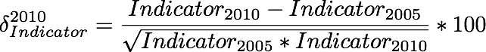

Readiness Categories and Indicators In Depth
The Readiness indicators aim to measure a country’s existing preparations and ability to adapt to a changing climate. This focus is similar in spirit to the World Bank’s Country Policy and Institutional Assessment (CPIA) measurements, which determine development assistance funding for low income countries based on performance in implementing policies that promote economic growth and poverty reduction.
We reviewed many different economic indices, such as the Word Bank’s Doing Business Indicators, the Heritage Foundation’s Index of Economic Freedom, and Transparency International’s Corruption Perception Index. There is clear overlapping among these, as a sub-component of one index will be based on a sub-component of another. To minimize overlapping, we use a minimum of indices that cover most of the information concerning effective economic governance and human development. Still, as a general trend, these indicators align with each other, and with GDP (or GNI) per capita. As such, we can also investigate deviations from the GNI trend as, e.g. countries with extensive oil resources.
Currently, we provide both “Readiness” and “Improvement in Readiness” scores. Hence, while Country A and Country B may score equally for Readiness, Country A’s improvement in the last 5 years on these indicators may be considerably more. This information is important to investors who may want to invest in riskier but high return countries (low initial Readiness but significant improvement in Readiness). As Daniel Kaufmann has emphasized, users and end clients are often primarily concerned with determining how they can improve upon indicators measured -- breaking our analysis down into improvement in Readiness can help users interested in improving measure this progress.
Partitioning Readiness into governmental, economic, and social indicators can communicate to countries and investors how countries are performing in these three areas. In addition, users of the index can more easily pinpoint specific indicators of interest through this partitioning.
GaIn™ intends to develop a fourth category, “Awareness,” to complement these three categories. This category would be subjective and provide information on whether national and local governments are aware of how sensitive their jurisdictions are to climate impacts and, if so, how they plan to adapt.

Economic
Indicator 1: Index of Economic Freedom [Heritage Foundation]
Component Indicators: Business freedom, trade freedom, fiscal freedom, government spending, monetary freedom, investment freedom, financial freedom, property rights, freedom from corruption, labor freedom.
Explanation: This indicator uses information from the Doing Business Index and the Corruption Perception Index while covering several additional economic variables. Particularly for the investment community, this indicator reflects the ability of a country to move quickly and effectively to address climate challenges. Improvements indicate that a country is better able to efficiently and quickly utilize investment capital.
Coverage: 183 countries
Access: Data available online.
Credibility: Credible. Produced by The Heritage Foundation and Wall Street Journal.
Effectiveness: Good. Comprehensive. Includes key indicators of concern to investors.
Longevity: In existence since 1995. While the Heritage Foundation and Wall Street Journal are prominent in their fields, NGOs can change, merge, or lose funding.
Source: http://www.heritage.org/index/

Social
Indicator 2: Human Development Index [UNDP]
Component Indicators: Health (Life expectancy at birth), Education (Mean years of schooling and Expected years of schooling), Living standards ( Gross national income per capita)
Explanation: Index reflects the health of the people within a nation and overall human capital. Improvement in this indicator reflects the increased readiness of the population to provide the necessary human capital to implement adaptation initiatives.
Coverage: 177 countries
Access: Yes. Online.
Credibility: Very credible. Conducted by UNDP since 1990.
Effectiveness: Good.
Longevity: In operation since 1990.
Source: http://hdr.undp.org/en/statistics/hdi/

Indicator 3: Mobile cellular subscriptions (per 100 people) [ITU]
Component Indicators: Mobile cellular subscriptions (per 100 people)
Explanation: Mobile phones serve as a proxy for infrastructure and access to information and knowledge. They are relevant in many sector and activities, such as personal communications, enabling new economic ( e.g. microfinance), healthcare management or crisis response, among others.
Coverage: 233 countries
Access: Online.
Credibility: Very Credible. ITU.
Effectiveness: Good. Not tested or used in other models. Makes sense to GaIn™ for now.
Longevity: Strong longevity, unless a new technology appears that replaces the usefulness of mobiles as an indicator. This data has been gathered since 1980.
Source: http://data.worldbank.org/indicator/IT.CEL.SETS.P2

Governance
Indicator 4: World Governance Indicator - Voice & Accountability
Component Indicators: Comprised of many indicators. Part of the World Governance Indicator.
Explanation: This indicator reflects the ability of a country to respond to its people’s natural resource allocation needs. Improvement indicates that a country’s government will be more responsive to the biophysical and capacity needs of its citizens as the climate changes.
Coverage: 199 countries
Access: Yes.
Credibility: Very credible. World Bank
Effectiveness: Good.
Longevity: Around since 1996. Should be published for foreseeable future unless underlying methodology changes.
Source: http://info.worldbank.org/governance/wgi/resources.htm

Indicator 5: World Governance Indicator - Political Stability & Absence of Violence
Component Indicators: Comprised of many indicators. Part of the World Governance Indicator.
Explanation: This indicator measures the public perceptions of the likelihood that the government will be destabilized or overthrown by unconstitutional or violent means, including domestic violence and terrorism. Improvement means a greater assurance to investors that their invested capital will grow without significant interruption and not be wiped out by political upheaval.
Coverage: 199 countries
Access: Yes. Many “background” indicators that one must parse
Credibility: Very credible. World Bank
Effectiveness: Good.
Longevity: Around since 1996. Should be published for foreseeable future unless underlying methodology changes.
Source: http://info.worldbank.org/governance/wgi/resources.htm

Indicator 6: World Governance Indicator - Government Effectiveness
Component Indicators: comprised of many indicators. Part of the World Governance Indicator.
Explanation: Captures perceptions of the quality of public services, the quality of the civil service and the degree of its independence from political pressures, the quality of policy formulation and implementation, and the credibility of the government's commitment to such policies. Improvement in this indicator reflects a country’s ability to respond to the needs of its citizens.
Coverage: 199 countries
Access: Yes.
Credibility: Very credible. World Bank
Effectiveness: Good. Possibly too similar to IEF, but greater focus on government effectiveness for its citizens versus a good investor environment.
Longevity: Around since 1996. Should be published for foreseeable future unless underlying methodology changes.
Source: http://info.worldbank.org/governance/wgi/resources.htm

Adaptometer

Information from the field that describes the level of knowledge, the policies in place, the allocation of budgets, and the overall commitment of society to adapting to climate change and other global trends. Concretely, polling/questionnaires will be conducted on public officials at national and local levels, plus representatives of the private sector, civil society, unions, universities, and think tanks.
This will capture a society’s awareness, the reality on the ground. Does a society understand its climate risks? What are the prospects of change in the right direction for increasing adaptation capacity?

Vulnerability Categories and Indicators in Depth

Our use of vulnerability seeks to capture exposure to climate related hazards, sensitivity to their impacts and the ability to cope with those impacts; or in simple terms it is a measure of exposure minus resiliency. This concept is derived from a more detailed definition from the IPCC Fourth Assessment Report: “Vulnerability is the degree to which a system is susceptible to, and unable to cope with, adverse effects of climate change, including climate variability and extremes. Vulnerability is a function of the character, magnitude, and rate of climate change and variation to which a system is exposed, its sensitivity, and its adaptive capacity.” In essence, our working definition combines exposure and sensitivity into “exposure” and subtracts “resiliency” (adaptive capacity).
This format aligns with Dr. Caroline Sullivan’s note during the Oct. 2010 meeting that exposure, sensitivity, and adaptive capacity capture different elements of vulnerability. With adaptation being the “procedural response to a real or perceived threat.”
Further, we utilize the framework of Hans-Martin Fussel of the Potsdam Institute for Climate Impact Research to identify our exposure and resiliency indicators (Fussel, 2010). Fussel explicitly uses the IPCC definition to categorize indicators for four climate-sensitive sectors -- water, food, health, and coasts. We feel that this model reflects the goals of GaIn™ for several reasons:
● Operating within the IPCC framework helps us communicate and compare with other efforts more easily and authoritatively -- “the IPCC said this, let's start here.”
● The division of indicators into "biophysical sensitivity," exposure," and “capacity” allows us to better communicate which indicators are actionable and those that are less so. For instance, capacity indicators = actionable indicators, indicators that countries can quickly change. Biophysical and exposure indicators are less actionable and might involve decades to improve, because they may require controlling population distribution or altering the physical landscape. Another way to describe these indicators is “slow”, “medium“ and “fast” indicators.
● Several other adaptation models provide useful ideas for developing indicators and/or values for country performance. However, many of these do not categorize indicators in way that allows countries or investors to measure performance.
- This approach compliments previous GaIn™ discussions that enhancement of adaptive capacity targets social rather than biophysical vulnerabilities and that we must recognize that there are absolute barriers that may prevent some resilience.

A number of existing vulnerability models have been called into question due to underlying methodological problems, inconsistent data comparisons among existing methodologies, and results that challenge assumptions of vulnerability.[2] Thus, at present, we believe our value added is not proving that our vulnerability model is the best for predicting the exact vulnerability levels of countries, but in signifying how countries can improve their resiliency to climate change.

Further, like Readiness, our Vulnerability score is correlated with GDP, indicating that we could just use GDP as an overall indicator. However, by organizing our indicators as we do we help countries and investors to target specific sectors vulnerable to climate change.

Biophysical exposure and impact

Indicator 7: Water - Future precipitation [CRU]
Explanation: Median % increase in precipitation from 9 climate models. Ian Noble computed for each country the median projection of 9 different GCM climate scenarios held by the UK-based Climate Research Unit. While improvements in modeling and uncertainty can change projections, this approach provides a general assessment of purely physical changes in future water supply. Ian Noble has suggested that “water runoff indicators” may be a better signal, however we have not yet found a suitable source of data.
Coverage: 187 countries
Credibility: Yes
Availability: Yes. Online.
Effectiveness: Total future runoff, if data becomes available, may be a better indicator.
Longevity: Models, regardless of the compiling institution, will continue to be created and improved
Source: http://www.cru.uea.ac.uk/

Indicator 8: Food - Crop yields [Wheeler, 2011]
Component Indicators: Agricultural Productivity Loss
Explanation: Wheeler bases predictions of future agricultural productivity changes on the results of Cline (2007). Cline’s data set uses midrange IPCC emissions forecasts, central tendencies in temperature across a number of Global Circulation Models, and combined estimates from technical and economic models of farmers’ responses to changing weather conditions. The resulting number is clearly a biophysical indicator because it does not take into account human exposure/dependence on crop production, just total production.
Coverage: 233 countries (187 used)
Credibility: A recent working paper, but Wheeler is respected in the field
Effectiveness: Crops yields are a very difficult indicator to predict, either go with the best (probably the Cline model) or seek another indicator that is easier forecast
Availability: Yes. Online
Longevity: Uncertain, modifications to such studies will likely frequently take place
Source: http://www.cgdev.org/content/publications/detail/1424759

Indicator 9: Health - Climatic disaster
Component Indicators: Climatic disasters per capita (95)
Explanation: People affected by climatic events (floods, fires, droughts, and storms) in recent decades as measured by CRED (Centre for Research on the Epidemiology of Disasters) data through its searcheable database. This represents a direct measure of the current threat of climate hazards to human populations and the health consequences that follow.
Coverage: 187, countries without disasters are not reported.
Credibility: Very credible.
Effectiveness: Good. Will need to explain and justify “people affected.” There may be other sub indicators to use.
Availability: Yes
Longevity: Yes. Data reporting has improved in last few decades and is expected to continue to improve.
Source: http://www.cred.be/

Indicator 10: Coastal Zones - Percentage of Land Below 5 meters [PLACE II]
Component Indicators: Percentage of Land Below 5 meters.
Explanation: Amount of coastline below 5 meters reflects likelihood of physical impacts on coasts as sea levels rise and storm surges move further inland.
Coverage: 228 countries.
Credibility: Credible. Columbia University. Often cited by other models. (Suggested by Fussel, 2010)
Effectiveness: Good. This indicator is often used by other models. Is 1 meter, 3 meters, 10 meters a better indicator?
Availability: Yes
Longevity: This data will be available regardless of institutional longevity
Source: http://sedac.ciesin.columbia.edu/place/

Socioeconomic exposure

Indicator 11: Water - Annual freshwater withdrawal [WB]
Component indicators: Annual freshwater withdrawals, total (% of internal resources).
Explanation: Measured as % withdrawal of internal freshwater resources. Countries already straining water resources will be particularly affected by significant alterations in precipitation patterns (coupled with population growth).
Coverage: 187 countries
Credibility: World Bank. (Suggested by Fussel, 2010)
Effectiveness: Good. Are there other indicators better representing dependence on freshwater relative to availability?
Availability: Yes. Online.
Longevity: Yes. World bank.
Source: http://data.worldbank.org/indicator/ER.H2O.FWTL.ZS

Indicator 12: Food - Rural % of total population [WB]
Component Indicators: Rural population (% of total population)
Explanation: Rural populations are typically more dependent upon local agriculture for basic sustenance.
Coverage: 187 countries
Credibility: World Bank. (Suggested by Fussel, 2010)
Availability: Yes. Online
Effectiveness: Good, though other indicators beyond rural could be considered
Longevity: Yes.
Source: http://data.worldbank.org/indicator/SP.RUR.TOTL.ZS

Indicator 13: Health - Doctor/Nurse numbers [WB]
Component indicators: Medical Support Index (2*Doc + Nurse)
Explanation: Medical providers per 1,000. People in a country with a low ratio will have greater exposure to disease and deaths from natural disasters and disease. Data shows that countries have about twice as many nurses as doctors, so the 2x weighting gives approximately equal rating to both professions.
Coverage: 187
Credibility: World Bank
Availability: Yes. Online.
Effectiveness: Good.
Longevity: Yes.
Source: http://data.worldbank.org/indicator/SH.MED.NUMW.P3

Indicator 14: Coastal zones - Population near sea level [PLACE]
Component indicators: Percentage of country population below 5 meters
Explanation: A higher number means citizens in coastal zones (<5m) will be exposed to higher economic costs, infrastructure damage, and morbidity.
Coverage: 228 countries.
Credibility: Credible. Columbia University. Often cited by other models. (Suggested by Fussel, 2010)
Availability: Yes
Effectiveness: Good. Distance from coast, natural coastal buffers, current infrastructure might be alternatives for differentiating risk.
Longevity: Yes.
Source: http://sedac.ciesin.columbia.edu/place/

Socioeconomic adaptive capacity/resilience

Indicator 15: Water - Access to Sanitation [WB]
Component indicator: Access to an improved water source
Explanation: A useful measure of how well-equipted a country is to address current and future water distribution and access challenges.
Coverage: 183
Credibility: World Bank. (Suggested by Fussel, 2010)
Effectiveness: Good. Other indicators such as “improved water source” or basic water access might more effectively cut to the point. Since this is in the adaptive capacity category, we may want to produce several target indicators.
Availability: Yes
Longevity: Yes.
Source: http://data.worldbank.org/indicator/SH.STA.ACSN

Indicator 16: Food - Hunger [WB]
Component indicator: Depth of hunger (kilocalories per person per day)
Explanation: Basic indicator of whether a country's food systems and infrastructure are working effectively.
Coverage: 183
Credibility: World Bank
Effectiveness: Medium A broad indicator. Perhaps there are other, more direct indicators capturing whether the food infrastructure can quickly adapt or if food systems are equitable.
Availability: Yes. Online
Longevity: Yes
Source: http://data.worldbank.org/indicator/SN.ITK.DPTH

Indicator 17: Health - Infant mortality [WB]
Component indicator: Infant mortality per 1000
Explanation: Indicates the degree to which the health system is delivering basic services.
Coverage: 187 countries
Credibility: Yes.
Effectiveness: Good. A general indicator for health services. We may want to branch out to more climate sensitive indicators.
Availability: Yes. Online.
Longevity: Yes.
Source: http://data.worldbank.org/indicator/SH.DYN.MORT

Indicator 18: Coastal Zones - Coastal zone wealth [Noble]
Component Indicator: $PPP/area_lecz (landlocked = 1.5 times the average score of non-land-locked countries).
Explanation: Measured as purchasing power parity divided by Low-elevation Coastal zone (“area_lecz”). Serves as a proxy to indicate the resources available to invest in coastal protection.
Coverage:
Credibility:
Availability:
Effectiveness: Alternatives would likely be based on more complex and less transparent modeling (E.g. DIVA).
Longevity:
Source: $PPP from World Bank

Energy/Other sectors
Energy is an additional sector that GaIn™ will most likely address next. Most adaptation models focus on food, water, coastal protection, or health, so GaIn™ has sought to used indicators on which the most work has been conducted. However, energy is certainly important in the context of climate change and resource constraints. Fossil fuel-based (primarily electric utilities), nuclear, and hydroelectric energy sources may be highly sensitive to shifts in water levels/provisions. Further, power lines and energy transmission systems may be susceptible to disruption for increasing storm intensity.

A preliminary biophysical indicator could include “damage to energy infrastructure from natural disasters.” A socioeconomic indicator could include “percentage of energy dependent on water resources/ecosystem services.” An adaptive capacity indicator could include “variety of energy sources in a country” or “percentage of people with access to electricity.” Further review and internal consultation will take place.

Other sectors could include “infrastructure” or “economic dependence on ecosystems.” However, these categories may be too broad for our focus on taking action in specific sectors.

Results

Ranking

Ranking by total score showing the Indicators (and a sub-selection of countries). High-resolution version.

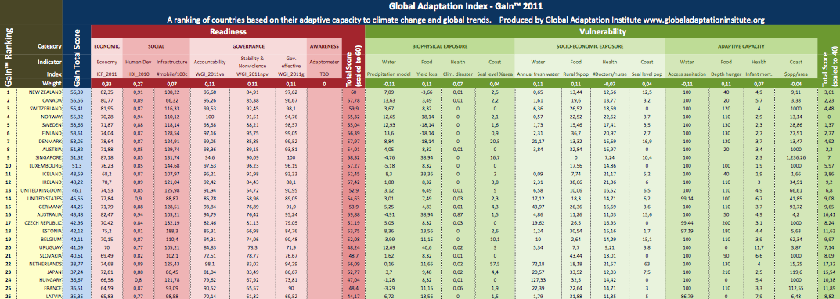

Readiness Bar plot

Countries ordered by Readiness score. Click for interactive plot.
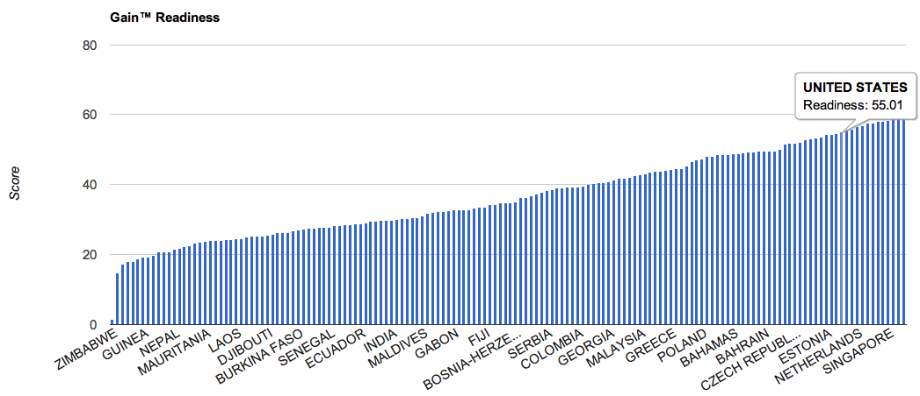

Vulnerability Bar Plot
Countries ordered by Vulnerability score. Click for interactive plot.
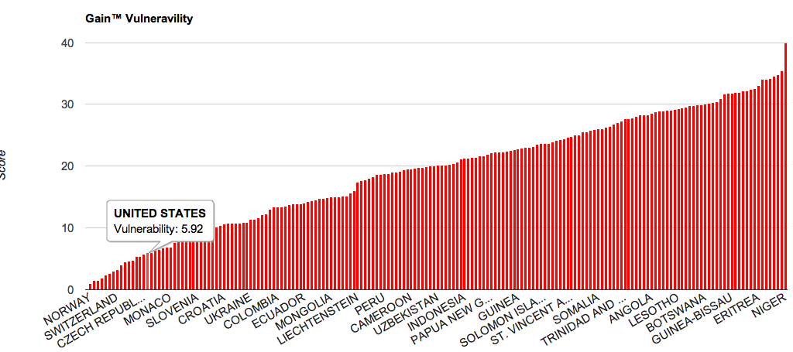

Stacked bars
Countries ordered on the horizontal axis by total Score. Blue positive and red negative stacked bars are, respectively Readiness and Vulnerability. Click for interactive plot.

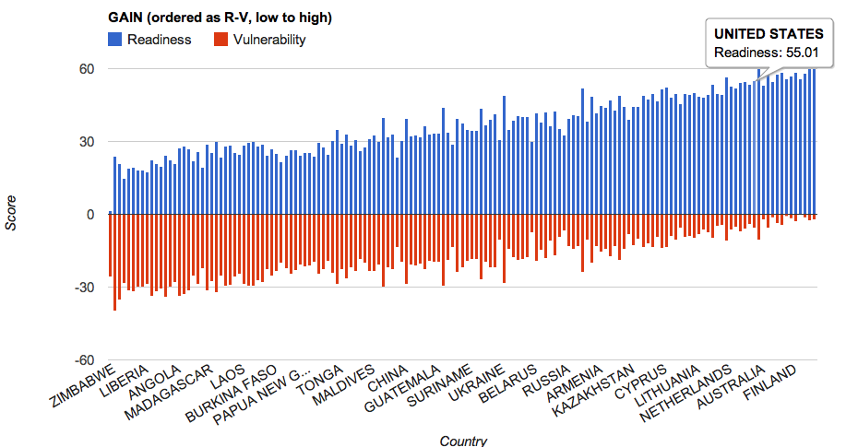

Gain™ Map
Ranking map. Blue shade countries have higher scores in Readiness than Vulnerability. Red shades countries have higher scores in Vulnerability than Readiness. (live draft version available here)

-map to be included-

Matrix
(Ignore Year labels). Click for interactive matrix (then click on “Matrix” tab)
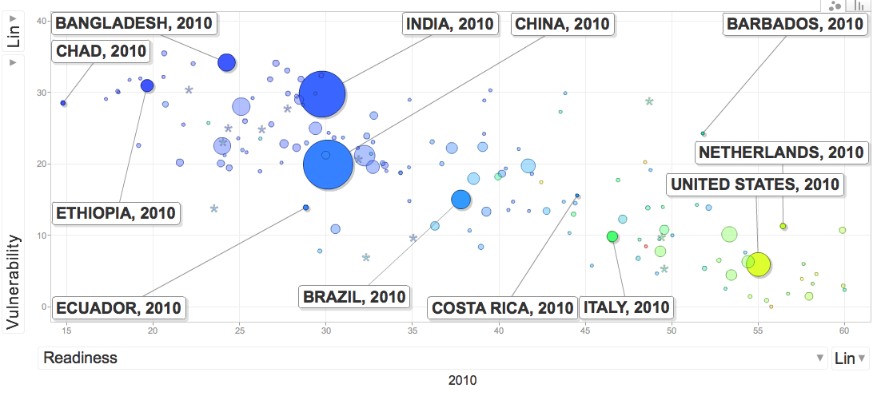

On the image above:
Abscissa Readiness
Ordinates Vulnerability
Size Population
Color GDP per capita
- For orientation purposes, some countries are labeled.

Change in readiness

See live here

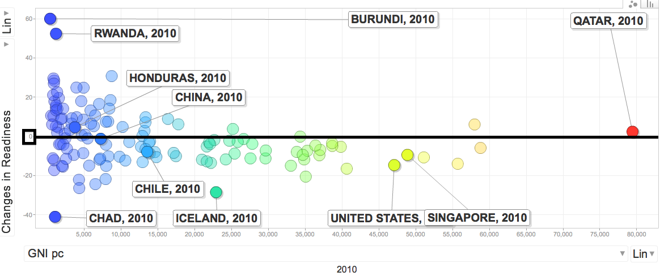

An additional dimension we provide is the deltas (% change) over the last 5 years for each of the indicators used in Readiness. We aggregate the z-values of these deltas using the same weights as for the levels. We use z-values to take into account the different stddev in each case.

On the GDP correlations

In general terms GNIpc correlates both with Readiness (more strongly) and with Vulnerability.

The following graphs show the apparent correlation of the “order of magnitude of GDPpc” (log GDPpc) with Readiness, Vulnerability, Total Score, and change in Readiness (size is population for all of them). All graphs are available here (“Matrix” tab), selecting the appropriate options for the axis.

log(GNIpc) vs Readiness (color is Vulnerability)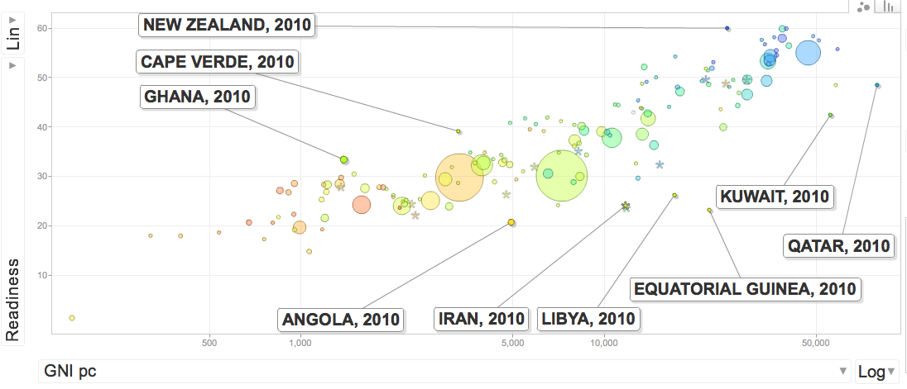

Log(GNIpc) vs Vulnerability (color is Readiness)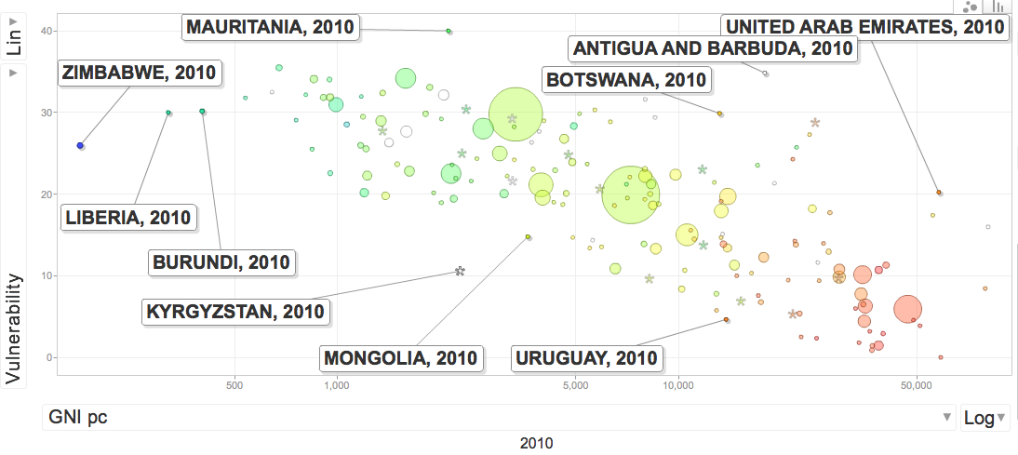

Log(GNIpc) vs change in Readiness (color is readiness)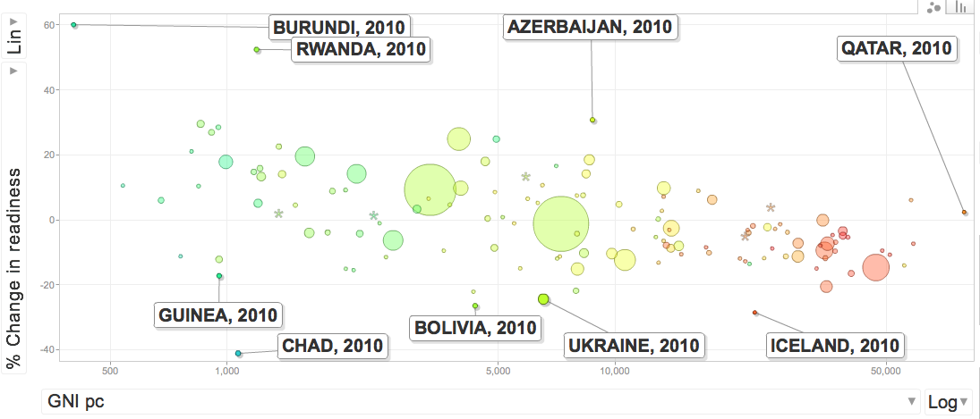

Moving forward

1. Background track. Framework software implementation. Define a more robust framework for implementation that maximizes transparency and availability. Candidates are Drupal+R+Google API.

2. Continue to receive input and advice from in-house experts.

3. Ensure internal agreement on indicators, thought process, and underlying assumptions.

4. Seek out, and implement advice and comments from selected collaborators and experts:
a. Add/remove indicators
b. Reconceptualize categories if necessary

5. Prepare model and documentation for Join Board meeting May 2 and 3, 2011

6. Implement comments, changes. Prepare for Board approval.

7. Unveiling and roll out strategy. Prepare for community-wide comments.

APPENDIXES

A- Bibliography

Climate Research Unit. http://www.cru.uea.ac.uk/

EM - DAT. The International Disaster Database. Center for Research on the Epidemiology of Disasters - CRED. http://www.emdat.be/

Fussel, Hans-Martin. 2010. How inequitable is the global distribution of responsibility, capability, and vulnerability to climate change: A comprehensive indicator-based assessment. Global Environmental Change (20) 597-611.

Fussel, Hans-Martin. 2009. Review and Quantitative Analysis of Indices of Climate Change Exposure, Adaptive Capacity, Sensitivity, and Impacts. Background note to the World Development Report 2010. World Bank, Washington, D.C. http://wdronline.worldbank.org/worldbank/a/nonwdrdetail/145

Index of Economic Freedom. 2011. Heritage Foundation and Wall Street Journal. http://www.heritage.org/index/

Kaufmann, Daniel, Kraay, Aart, & Mastruzzi, Massimo. World Governance Indicators. World Bank. http://info.worldbank.org/governance/wgi/index.asp

SEDAC, 2007. National Aggregates of Geospatial Data Collection. Population, Landscape and Climate Estimates (PLACE). http://sedac.ciesin.columbia.edu/place/

UNDP. Human Development Index. http://hdr.undp.org/en/statistics/hdi/

Wheeler, David. 2011. Quantifying Vulnerability to Climate Change: Implications for Adaptation Assistance - Working Paper 240. Center for Global Development. http://www.cgdev.org/content/publications/detail/1424759

World Bank. Country Policy and Institutional Assessments (CPIA), 2009 Assessment Questionnaire. September 10, 2009.

World Bank Development Indicators (WDI). World Bank.
http://www.data.worldbank.org/indicators

World Telecommunicationn/ICT Indicators Database. International Telecommunications Union. http://www.itu.int/en

Complete List available here.

Submission form available here (anyone can send reviews): http://bsan.eu/Gain_biblio_form

B- Methodology
Normalization
Score values are converted to standard scores (z-values). Z-values subtract score values to the average score for all the countries, and then divide by the standard deviation of those scores. The resulting measure compares values relative to other countries in units of stdev. If all values are clustered, the unit is small (higher granularity). If values are dispersed, or a few deviate significantly from the mean, the granularity is coarse.

Evaluate
Orthogonality/Correlations
Indices are not perfectly orthogonal (Independent) between Readiness and Vulnerability, or even among Categories. We also do not assume that the set of indices is complete in terms of all parameters. We chose the smallest set of indices that provide the most information. Correlations among indicators and with other variables like GDPpc are possible and expected.

Missing or outdated data
If a country has missing data, we remove it entirely from the model. In some cases we fill the most sensible value. Like for example landlocked countries and sea-level rise effect, or adding a 0 value for victims on climate disasters in the CRED database.

C- Roadmap
-see attached document-

We use this indicator instead of 3 suggested by Fussel. This gets to the core concept and is more readily available than Fussel’s citations.

